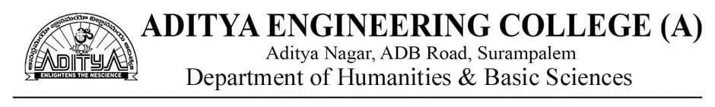

Program:B.Tech

Semester:I

Course Name: Communicative English Lab

Academic Year: 2020-21

**CO attainment Summary**

|  |  |  |  |  |  |  |  |
| --- | --- | --- | --- | --- | --- | --- | --- |
| **Course Name** | **Section** | **CO1** | **CO2** | **CO3** | **CO4** | **CO5** | **CO6** |
| COMMUNICATIVE ENGLISH LAB | A | 2.92 | 2.92 | 2.92 | 2.92 | 2.92 | 2.40 |
| B | 2.93 | 2.92 | 2.93 | 2.92 | 2.91 | 2.40 |
| C | 2.93 | 2.92 | 2.93 | 2.92 | 2.93 | 2.40 |
| D | 2.93 | 2.93 | 2.93 | 2.93 | 2.93 | 2.40 |
| Average | **2.92** | **2.92** | **2.92** | **2.92** | **2.92** | **2.4** |

**PO attainment Summary**

|  |  |  |  |  |  |  |  |  |  |  |  |  |  |  |
| --- | --- | --- | --- | --- | --- | --- | --- | --- | --- | --- | --- | --- | --- | --- |
| **Section** | **PO1** | **PO2** | **PO3** | **PO4** | **PO5** | **PO6** | **PO7** | **PO8** | **PO9** | **PO10** | **PO11** | **PO12** | **PSO1** | **PSO2** |
| A |  |  |  |  |  |  |  |  | 2.83 | 2.83 |  |  |  |  |
| B |  |  |  |  |  |  |  |  | 2.83 | 2.84 |  |  |  |  |
| **C** |  |  |  |  |  |  |  |  | 2.84 | 2.84 |  |  |  |  |
| D |  |  |  |  |  |  |  |  | 2.83 | 2.84 |  |  |  |  |
| Average |  |  |  |  |  |  |  |  | **2.83** | **2.83** |  |  |  |  |

**Course Coordinator Head of the department**



Program:B.Tech

Semester:I

Course Name: Communicative English Lab

Academic Year: 2020-21

**CO attainment Summary**

|  |  |  |  |  |  |  |  |
| --- | --- | --- | --- | --- | --- | --- | --- |
| **Course Name** | **Section** | **CO1** | **CO2** | **CO3** | **CO4** | **CO5** | **CO6** |
| COMMUNICATIVE ENGLISH LAB | A | 2.92 | 2.92 | 2.92 | 2.92 | 2.92 | 2.40 |
| B | 2.93 | 2.92 | 2.93 | 2.92 | 2.91 | 2.40 |
| C | 2.93 | 2.92 | 2.93 | 2.92 | 2.93 | 2.40 |
| D | 2.93 | 2.93 | 2.93 | 2.93 | 2.93 | 2.40 |
| Average | **2.92** | **2.92** | **2.92** | **2.92** | **2.92** | **2.4** |

**PO attainment Summary**

|  |  |  |  |  |  |  |  |  |  |  |  |  |  |  |
| --- | --- | --- | --- | --- | --- | --- | --- | --- | --- | --- | --- | --- | --- | --- |
| **Section** | **PO1** | **PO2** | **PO3** | **PO4** | **PO5** | **PO6** | **PO7** | **PO8** | **PO9** | **PO10** | **PO11** | **PO12** | **PSO1** | **PSO2** |
| A |  |  |  |  |  |  |  |  | 2.83 | 2.83 |  |  |  |  |
| B |  |  |  |  |  |  |  |  | 2.83 | 2.84 |  |  |  |  |
| **C** |  |  |  |  |  |  |  |  | 2.84 | 2.84 |  |  |  |  |
| D |  |  |  |  |  |  |  |  | 2.83 | 2.84 |  |  |  |  |
| Average |  |  |  |  |  |  |  |  | **2.83** | **2.83** |  |  |  |  |

**Course Coordinator Head of the department**